Blog / Article Page

Definition
# Source: AI Source: Provided by: [Data Path: Persons Table -> ID Column: 1, Name_En Column: Motasem Essam] -> From: [Chatgpt (GPT‑5 Mini)] on [2/12/2026]
A Blog / Article Page is a web page that displays written content such as articles, posts, tutorials, news, or stories for readers.

Simple Definition
# Source: AI Source: Provided by: [Data Path: Persons Table -> ID Column: 1, Name_En Column: Motasem Essam] -> From: [Chatgpt (GPT‑5 Mini)] on [2/12/2026]
Blog / Article Page = a page where information is shared through written posts.

What a Blog / Article Page Usually Includes
# Source: AI Source: Provided by: [Data Path: Persons Table -> ID Column: 1, Name_En Column: Motasem Essam] -> From: [Chatgpt (GPT‑5 Mini)] on [2/12/2026]
- Title / Headline – topic of the post
- Author name – who wrote it
- Date – when it was published
- Main content – text, images, videos, examples
- Categories / Tags – organize topics
- Comments section (optional) – readers can respond
- Related posts (optional) – links to similar articles

Purpose of a Blog / Article Page
# Source: AI Source: Provided by: [Data Path: Persons Table -> ID Column: 1, Name_En Column: Motasem Essam] -> From: [Chatgpt (GPT‑5 Mini)] on [2/12/2026]
- Share knowledge, tutorials, or news
- Teach or inform readers
- Improve website visibility (SEO)
- Build authority or personal/brand reputation
- Engage with an audience

Examples
# Source: AI Source: Provided by: [Data Path: Persons Table -> ID Column: 1, Name_En Column: Motasem Essam] -> From: [Chatgpt (GPT‑5 Mini)] on [2/12/2026]
- Coding tutorials (e.g., “How to Learn HTML”)
- News articles
- Travel or lifestyle blog posts
- Educational guides and tips

Difference Between Blog Page and Landing Page
# Source: AI Source: Provided by: [Data Path: Persons Table -> ID Column: 1, Name_En Column: Motasem Essam] -> From: [Chatgpt (GPT‑5 Mini)] on [2/12/2026]
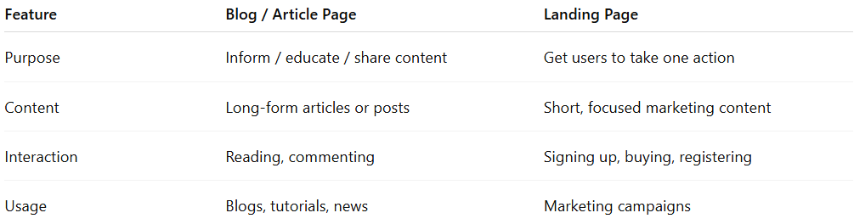
Feature | Blog / Article Page | Landing Page
Purpose | Inform / educate / share content | Get users to take one action
Content | Long-form articles or posts | Short, focused marketing content
Interaction | Reading, commenting | Signing up, buying, registering
Usage | Blogs, tutorials, news | Marketing campaigns

